
4 Ten-Frame Counting: How many dots are in the frame?
Number =
Number =
Student Name:
Teacher/Room:
Date:
Score / 100
Counting Objects and Write Numbers




1 Count the apples and write the number in the box:
Total Apples =
2 Count the bright stars and write the number:
Total Stars =
3 Count the friendly fish:
Total Fish =





5 Write the missing numbers in sequence:
1 , 2 , 3 ,
, 5 , 6 ,
, 8 , 9 ,
10 , 11 ,
, 13 , 14 ,
, 16 , 17 ,


6 Add the groups of balloons together:
+
=
2 3


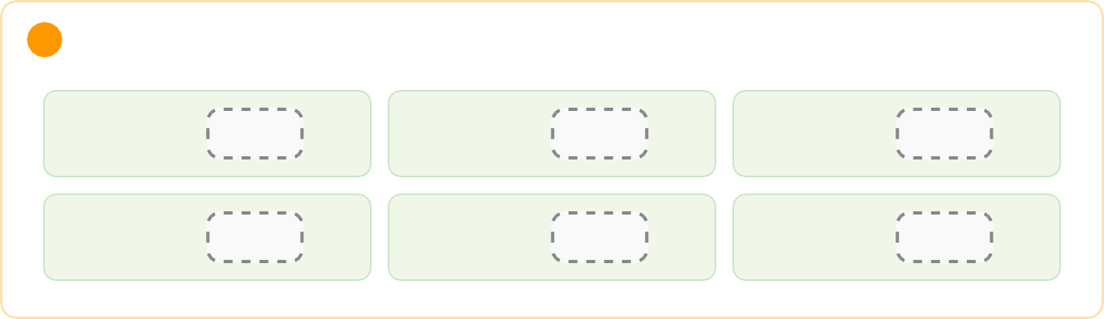
7 Add the tasty flowers:
+
=
4
2
8 Solve the addition problems:
3 + 3 =
5 + 2 =
4 + 4 =
6 + 1 =
7 + 2 =
2 + 8 =
9 Fill in the boxes to make 10:
5 +
= 10
7 +
= 10
2 +
= 10
8 +
= 10
1 +
= 10
6 +
= 10

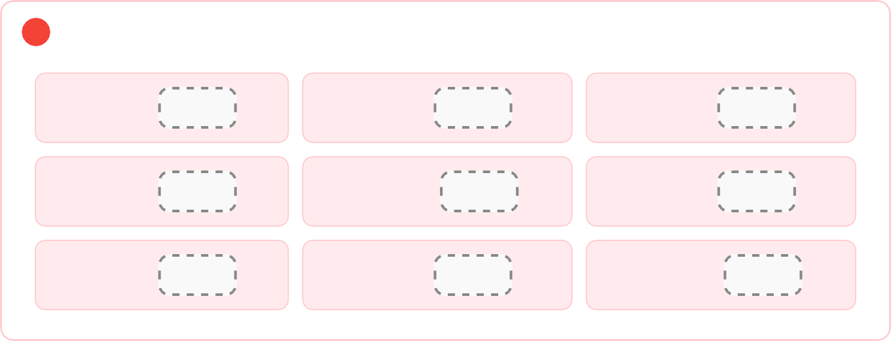
12 Solve the subtraction problems:

10 Cross out the items to subtract and write the remaining number:
A. Start with 6 cupcakes. Cross out 2 cupcakes ( 6 - 2 ):
6 - 2 =




11 Cross out to solve:
B. Start with 5 apples. Take away 3 apples ( 5 - 3 ):
5 - 3 =

7 - 2 = | 8 - 4 = | 5 - 1 =
9 - 3 = | 10 - 5 = | 6 - 4 =
4 - 2 = | 8 - 1 = | 10 - 2 =


13 Circle the BIGGER number in each pair:
8 or 3
5 or 9
12 or 7
15 or 18
14 Circle the SMALLER number in each pair:
4 or 10
11 or 6
14 or 20
9 or 2
15 Write > (greater than), < (less than), or = (equal to) in the box:
6
4
10
10
3
8
15
12
7
9
19
19
16 Order the numbers from SHORTEST to TALLEST (1, 2, 3):
Box A
Box B
Box C
Order:
Order:
Order:


17 Match the shape name to the picture (Draw a line):
Square
Triangle
Circle
Rectangle
18 Count the sides of each shape:
Sides =
Sides =
Sides =
Patterns and Sequences



19 What comes next in the pattern? Draw or name the shape:
Next shape is:
20 Complete the color/shape pattern:
Next shape is:

21 Skip counting by 2s:

2 , 4 , 6 ,
, 10 ,
, 14 ,
, 18 , 20
22 Skip counting by 5s:

5 , 10 ,
, 20 , 25 ,
, 35 ,
, 45 , 50
23 Skip counting by 10s:

10 , 20 , 30 ,
, 50 , 60 ,
, 80 , 90 ,

Place Value (Tens and Ones)
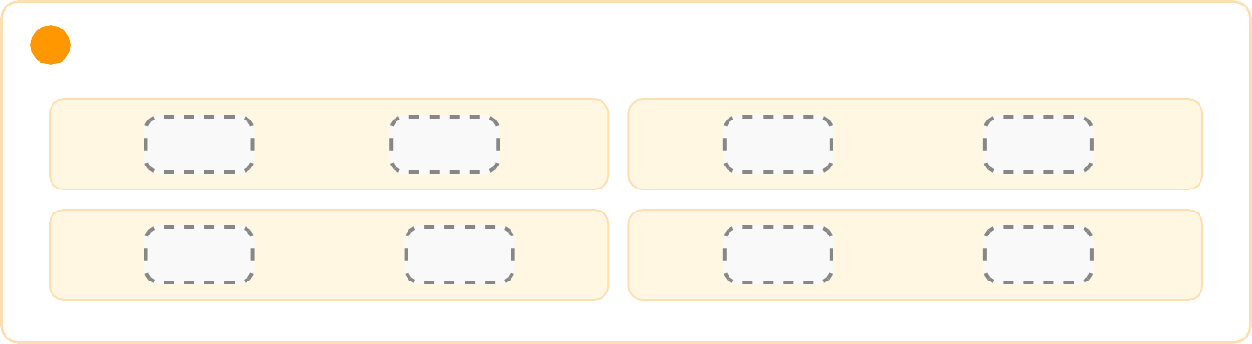
24 Count the tens blocks and ones blocks:
Tens +
Ones =
25 Break the numbers into Tens and Ones:
15 =
Ten and
Ones
24 =
Tens and
Ones
31 =
Tens and
One
48 =
Tens and
Ones
26 What total number is shown?
1 Ten + 8 Ones =
3 Tens + 2 Ones =
5 Tens + 0 Ones =


27 Read the clock and write the time:

12
12
12
9
3
9
3
9
3
6
6
6
Time:
Time:
Time:
28 Draw the hands on the clock:

12
12
9
3
9
3
6
6
4:00 o'clock
9:00 o'clock
Understanding Simple Fractions (Half & Quarter)
29 Which shapes are cut into HALF (1/2)? Circle them:
A
B
C
30 Write the fraction for the shaded part:
Shaded fraction =
Shaded fraction =
Shaded fraction =

33 Look at the Favorite Fruits graph:
- How many children like Apples?
- How many children like Bananas?
- Which fruit is liked the MOST?
31 Count the total dollars:
A.
$5
$5
$1
Total = $
B.
$10
$5
$2
Total = $
32 How much money is needed?
Toy Car = $8
You pay $10
Book = $6
You pay $10
Change back = $
Change back = $
Picture Graphs and Data

Fruit | Number of Children
Apple
Banana
Orange

34 Add the 2-digit numbers:
1 2
+ 1 5
2 3
+ 2 1
3 0
+ 1 4
4 2
+ 3 5
35 Solve horizontal additions:
20 + 10 =
15 + 12 =
33 + 11 =
40 + 25 =
2-Digit Subtraction (No Borrowing)
36 Subtract the 2-digit numbers:
2 8
- 1 4
3 5
- 2 2
4 9
- 1 6
5 7
- 3 0
37 Solve horizontal subtractions:
30 - 10 =
25 - 12 =
48 - 20 =
55 - 15 =




38 Measure the pencil using ruler units:
Length of Pencil =
units
40 Find the value of each symbol:

0 |  | 1 |  | 2 |  | 3 |  | 4 |  | 5 |  | 6 |  | 7 |  | 8 |  | 9 |  | 10

39 Which object is HEAVIER? Circle it:
Rock
Feather
Simple Word-Free Picture Logic & Challenges

+ | = 10 | So, | =
+ | = 9 | So, | =
+ | = 8 | So, | =

41 Fill in the Missing Numbers (Number Bonds to 15):
10 +
= 15
8 +
= 15
12 +
= 15
42 Final Star Challenge:
Draw 12 stars in the box below:

