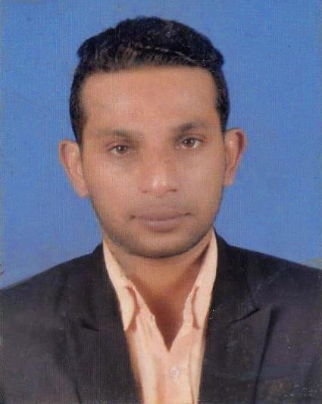
Dewamuni Shashi Binon Jayathilaka

No 57/3, Batakaththara.Madapatha Road,Piliyandala 0094768325497 / 0094765604502 binonjayathilakaa@gmail.com

Profile…….
With the knowledge and skills I have acquired, my ambition is to work in a reputed organization where I could further enhance my creativity, knowledge and skills while sharing my knowledge and experience productivel y with my employer and also I believe my quick learning and easy adaptation skill will help me to do my job successfully.

Career Objective…….
- To take up a responsible position in a dynamic and growing organization.
- To achieve personal development by being accountable and responsible to the assigned task.
- Using my skills to solve the challenges in the organization to achieve its goals

Employment History………

❖ 2011 to 2015 April (04Yers): DEMONSTRATOR + MIDICAL REPRESENTATIVES
Swiss Biogenic Limited, 27-4/1, York Arcade Road, Colombo 01, Sri Lanka.

Job Responsibilities……..

- Coordinating with Customer and Obtain Oder obtaining the required raw materials on time to Outlet Preparing development costing.
- Handling inquiries
- Direct negotiation
- Communicate and work closely with internal teams and Client Follow up with Clients for deliveries.
- Providing customer with new developments every season keeping in view the Brand’s requirements and its interest.
- Maintaining weekly order status reports
- Minimize the Wastage
- Coordinate With Outlet Manager and Increase Daily Sale with Out any Hostage.
- Visit the Doctors to get the Fresh Oder
- Support to All the Medical Representative to Build Customer relationship better.
- Demonstrate to Client as required
- User free with Novo rapid, Act rapid, Novo mix & Mixture flex pen

❖ 2015 to Present (05Years) : Manager Marketing (ENGINEERING)
Kent Engineers (Pvt) Ltd. No 27, Malwaththa Avenue, Kohuwala,, Sri Lanka (Mechanical,
Electrical & Plumbing)

Job Responsibilities:

- Coordinating with sites to obtain orders.
- Material Receive & GRN
- Separate the Site Return and Arrange the Supplier Return
- Handling the Import & export(Maldives, Bangladesh and seashell)
- Direct negotiation with suppler & buying offices
- Stores Arrangement According To OSHAS & ISO 9001-2015
- Preparing Each & Every Sites monthly and annual cost
- Maintain Minimum Buffer Stock
- Maintain Quality of Material & Arrange the On time Delivery to sites.
- Raise Purchase Requisition Related to Site Requirement
- Maintain Discipline all the Store Keepers (08) and stores Helper.
- Raise a Transport Requisition according to the site requirement.
- Maintaining weekly order status reports and projection reports.
- Check and Authorized All the Invoices before send it to Account Department.
- Performing general data entry using ERP System

KEY SKILLS……..

- Ability to work in computerized environment.
- Ability to work in teams and provide innovative ideas.
- Ability to work independently and under pressure.
- Ability to develop positive working relationships.
- Self-Motivated and also I have Positive Mental Attitude
- And also Deadline Driven, Quick Learner who’s Open to Change and New Learning Opportunities.
- People Management as Company Need.

Educational Qualifications…….

- GCE O/L examination – 2003 (5A + 3B)
- GCE A/L examination – 2006 [1B+3C(Science Stream)]

Professional Qualification…….

- Successfully Completed Business Management Degree [BSc (Hons)] at CINEC
MARTIME CAMPUS (CINCE), Malambe with combined North Umbria University. (U.K) 2007 - 2010
- Successfully completed extension course Fire Prevention and Fire Fighting at CINEC MARTIME CAMPUS Malambe Sri Lanka - 2006
- Successfully completed extension course Personal Safety and Social Responsibilities at CINEC MARTIME
CAMPUS Malambe Sri Lanka - 2006
- Successfully completed extension course Fire Personal Survival Techniques at CINEC MARTIME CAMPUS Malambe - 2006
- Successfully completed extension course Elementary First Aid at CINEC MARTIME CAMPUS Malambe – 2006

Extra-Curricular Activities…….

- Member of school Cricket(Frist 11) team (U-13,U-15, U-17, U-19)
- Member of Science Cricket Academy
- Member Of Science Badminton Teem.
- Member of school Sinhala literary club. (2005-06).
- Member of CINEC International Swimming Gold Academy and Water Sports.

Personal Details…….

Name With Initials |  | : D.Shashi Binon Jayathilake
Date of Birth |  | : 30.12.1986
Gender |  | : Male
Nationality |  | : Srilankan
Religion |  | : Buddhist
Marital Status |  | : Married
School |  | : Nalanda Collage Colombo 10
N.I.C Number |  | : 863654297V

Referees……..

Mrs.W.S Sewandi Alwis
Project Manager
Kent Engineers (PVT) Ltd.
No.27
Malwathtta Avenue
Kohuwala
Nugegoda
Sri Lanka.
Tel: 0094765604502/00941127212035
sewandi@kentengineers.net

Mr. I Anuranga Fonseka
Manager Operation
Flow Tech Engineering (PVT) Ltd
No.201-B
Highlevel Road
Nugegoda
Sri Lanka
Tel: +94117675675 Mobile: +94768257902
sales@flowtecheng.com

I hereby certify and declare that the details furnished above true and correct to the best of my knowledge.

Name: D.S.B.Jayathilaka Date: …………………..

