Informatics Institute of Technology
Department Of Computing
BSc (Eng) Software Engineering

Module: 4COSC008C.2 Computer Science Practice

Coursework: 01

Individual Report

Student ID : 20191198
Course : Software Engineering
Date of Submission : 30th March 2020
Module Leader : Mr.Kaneeka Vidanage
Group No : H11
Topic : Bitcoin Ethics

Table of Contents
1. Abstract…………………………………………………………….. 3
2. Introduction………………………………………………………. 4
3. Literature Review
3.1 Advantages of Bitcoin………………………………………………………. 5
3.2 Disadvantages of Bitcoin…………………………………………………… 6
3.3 Ethics in Bitcoin………………………………………………………………… 7-8
3.4 Ethical Effects of Bitcoin……………………………………………………. 9
4. Methodology………………………………………………………. 10
5. Results & Discussion…………………………………………….11
6. Conclusion……………………………………………………………12
7. References…………………………………………………………. 13-14

- Abstract

Bitcoin is one of transaction in the world. This report about Bitcoin Ethics. It offers several benefits like fast transaction speeds, low costs, eliminate the need of 3rd party between the transaction, etc. Bitcoin regulators face resistance because technology has been used for malicious purposes. This report shows the basic ideas of Bitcoin Ethics and ethical effects. Bitcoin is a cryptocurrency and it is very useful. Also there are some risks too. In future modern world are going transaction with cryptocurrency, then Bitcoin will come one of a best transaction in the world.

- Introduction

Bitcoin was created between 2008 and 2009 by an individual, or group, acting under the name of Satoshi Nakamoto. Bitcoin is a type of Cryptocurrency. Cryptocurrency is a digital currency. A form of electronic cash. It is a decentralized digital currency without a central bank or single administrator that can be sent from user to user on the peer-to-peer bitcoin blockchain network without the need for intermediaries. It is powered through blockchain technology. Bitcoin is a digital currency and it is used everywhere and bitcoin is also purchased in cash and stored with bitcoin wallet. So today bitcoin is going to the moon because it is a convenient and reliable way of more money without working hard on yourself.

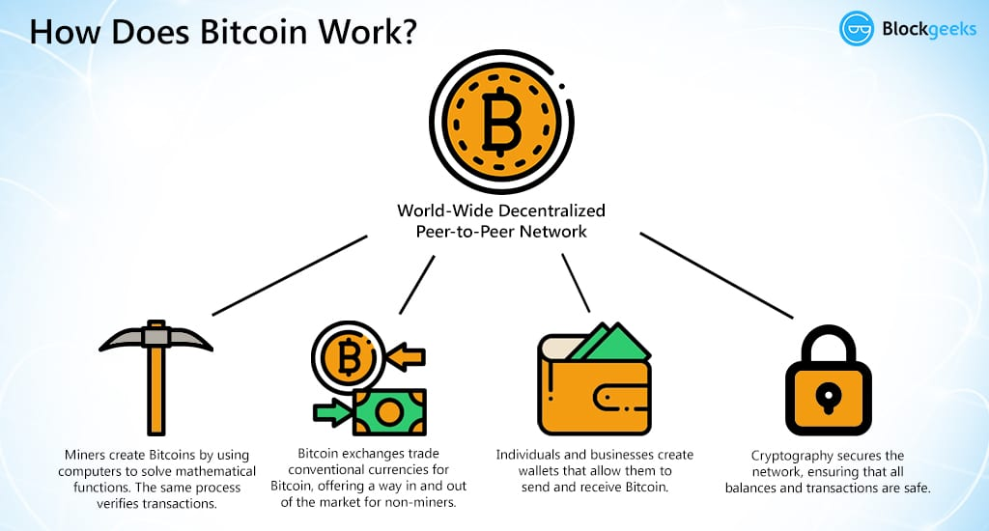2.1 Introduction for Bitcoin

- Literature Review
3.1 Advantages of Bitcoin
Bitcoin uses complex algorithms to guarantee the credibility of currency. Bitcoin is one of currency in market, and this Bitcoin can make it more distinctive than the other coins. Now I’m going to explain some advantages of this cryptocurrency coin.
. It is payment free. We can send and receive money anywhere in the world at any time. We don’t worry about the holidays, crossing boards, destination or any other reasons during transfer the money. In Bitcoin we have total control of our money.
.The other Advantage is Security and Control. Users can control their transactions, and helps to keep it is safe for the Network. Traders can’t charge the additional costs in Bitcoin. Also Bitcoin protects against the identity theft. Therefore we use a wallet for bitcoin to ensure money safety.

.Another very important advantage is that the information is transparent. All transactions visible for everyone, but personal information is hidden.

.Bitcoin is cryptographically safe. Therefore any company, persons, organizations can’t manipulated this.

.In Bitcoin there are no commissions charge or very small. To process transactions faster may be includes some fee.

. Due to the fact that Bitcoin transactions can’t be reversed, they do not contain personal information, and they are safe.

. Traders can do business where crime and fraud rates are high, because it's very hard to mislead someone in Bitcoin.

. Digital currency exchanges help the trader to process operations by converting bitcoins into fictitious coins. These services generally have lower fees than credit cards and PayPal.

3.2 Disadvantages of Bitcoin.

. Bitcoin we can list lack of notification and understanding. Many people still do not have the existence of digital coins and Bitcoin.

.Companies like to use Bitcoin because of the benefits. But the list is short compared to physical coins.

.In modern day Bitcoin price jumps from day to day.

. Bitcoin has yet to grow until it reaches its full potential.

.Bitcoin is in its infancy, but its improving well in the present days.

.In Some Countries most of people don’t have an idea about Bitcoin, so try to inform them about bitcoin.

.A normal person mean midrange person can’t use the Bitcoin in modern day. Because Bitcoin price is become very high in now days. So they can’t buy a Bitcoin to enrol with this cryptocurrency bitcoin system.

.In this system we are going to trusting with 3rd party.

.Also Bitcoin is Risk and Volatile system.

.Bitcoin wallet can be lost.
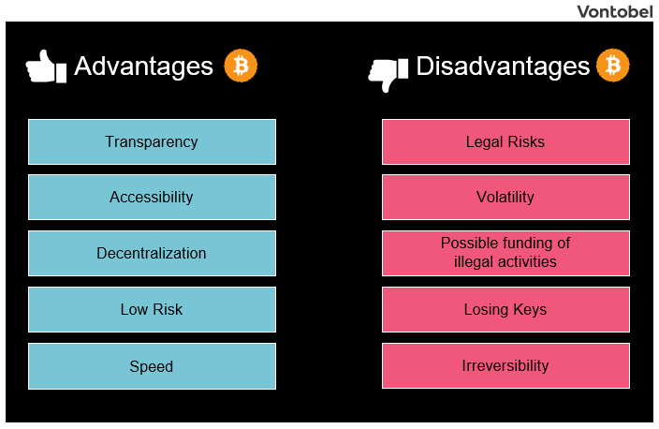

3.1(2).1table for advantages and disadvantages of Bitcoin.

3.3 Ethics in Bitcoin
Bitcoin is a set of code stored on the hardware of computers, which is not run independently but can only be used by human beings. Some people have a very negative view of the ethics of Bitcoin, and Nobel laureate economist Paul Krugman has gone so far as to condemn Bitcoin as an evil link, according to the New York Times. Such a statement provides a useful starting point for assessing the ethics of Bitcoin only for its obvious flaw. It can certainly be used for unethical ways, but calling it evil is like calling any other currency in the world evil. Because they can be and are sometimes used in unethical ways. When considering the ethics of Bitcoin, it is the use of money that should be examined.
One of the most frequent moral allegations against bitcoin is the anonymity of the money users, which allows them to engage in criminal activity in a non-financial way.
However, the anonymity level of those who use bitcoin is not complete. Initially, all transactions that use bitcoin are published on the blockchain because the parties to these transactions can be identified by their Bitcoin address, which acts as a pseudonym. Therefore, if a person can link to their address, it is no longer anonymous.
There are no taxes, commissions. Also Bitcoin is one of best easy transaction. It’s a peer to peer transaction and it is one speed transaction in the world. There are no any responsibility. And it is less of credibility. Also Bitcoin is safety up in some level. [[2] Angel, James J. (2014). The Ethics of Payment. Journal of Business Ethics & [3] Angel, J. and McCabe, D., 2020. The Ethics Of Payments: Paper, Plastic, Or Bitcoin]

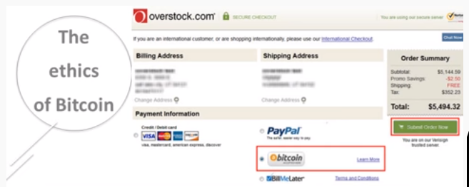
  - Ethics of Bitcoin

3.4 Ethical Effects of Bitcoin
If you have a nation that takes over cryptocurrency, it will definitely provide a way to achieve these moral goals of stability and security. One of the cool things about crypto money is that the value is secured by the community of users. If that community of users can create the stability and security of the value of money, then it can definitely be met for moral money.
Bitcoin be held ethically responsible for aiding crime. It is may be true why we don't live in a perfect world, the world without crime. Bitcoins definitely simplifies the work of criminals. While one might argue that criminals have other ways to deal with their money, Bitcoin greatly simplifies their work. Bitcoin transactions offer some advantages of privacy, but support for bitcoin is more like choosing privacy than security.
Also there are some ethical effects in below,
- Dark web
- Black market
- Bitcoin wallet hacking
- Bitcoin exchange hacking
- Purchasing goods
- Financial sector [[1] R. Upadhyaya and A. Jain, "Cyber ethics and cyber crime:]
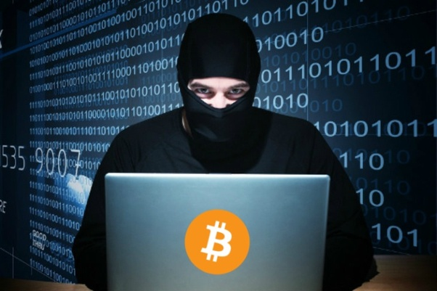
3.4. Bitcoin sticker and a mask to prevent him from being seen through the webcam.
- Methodology

I used several resources for get some information about Bitcoin. There are Google Scholar Research papers and Harvard cite for me research papers about Bitcoin. Also I got help from IEEE research papers. Then I searched some Youtube videos to get some information about Bitcoin. I could find videos in Sinhala and English. This Sinhala videos are one of a big help to get an idea about the Bitcoin. In day to day life Bitcoin is a one way for become rich. I could get some idea about Bitcoin Cryptocurrency system from this books, videos and papers. So I used these methods to write my report.

- Results & Discussion
As I said before Bitcoin useful currency for us. In modern day lots of people are using cryptocurrency system. So People are using Bitcoin.
Now days Bitcoin Value increasing very high. A year ago one Bitcoin cost about $800; today, it costs more than $17,000. So people going to buy Bitcoin to get more money.
We can use Bitcoin Blockchain system to some works. Like Clinical health data transfer and interactions, Drug supply chain integrity and consistency, Declaration of claims and billing management, Cyber ​​Care and Health Care Fund, etc.
Now I’m going to explain one of them below,

- Clinical health data transfer and interactions

Blockchain healthcare is often the first topic that data migration looks at. GadTime, a security database company in Denmark and the Danish EHealth Foundation recently, Eleven million health report users using their own keyless signature infrastructure (KSI) using blockchain technology. However, it will be difficult to replace the Estonian blockchain. Considering the complexity of data and data structures between public and private entities.
It is about Bitcoin blockchain system uses.

People will be changing in future, why lots of people don’t like use money, coins, etc. If cryptocurrency become among the people they turn transaction with cryptocurrency. Because it is very simple and effective. So I think cryptocurrency will run world in future world. So Bitcoin becomes the main idol of cryptocurrency.
As Bitcoin’s value is increasing very high day and day. So people try to learn about Bitcoin and become interesting about Bitcoin more than money and coins. I think in future world use BITCOIN. Why Bitcoin become more powerful transaction than money and coins.
- Conclusion

Bitcoin is type of a cryptocurrency. So I think it is easy transaction. But there are huge seriousness. I think it is legit and our money is fully secure. Bitcoin is a consensus network that enables a new payment system and a completely digital money. It is the first decentralized peer-to-peer payment network that is powered by its users with no central authority or middlemen. From a user perspective, Bitcoin is pretty much like cash for the internet. Bitcoin can also be seen as the most prominent triple entry bookkeeping system in existence. To benefits from Bitcoin we need Bitcoin wallet. In modern day Bitcoin value more than $17,000. So I think Bitcoin is a way to become rich or earn money. So I think in future Cryptocurrency become the main transaction system in the world.

- References

[1] R. Upadhyaya and A. Jain, "Cyber ethics and cyber crime: A deep dwelved study into legality, ransomware, underground web and bitcoin wallet", 2016 International Conference on Computing, Communication and Automation (ICCCA), 2016. Available: 10.1109/ccaa.2016.7813706 [Accessed 10 February 2020].

[2] Angel, James J. (2014). The Ethics of Payment. Journal of Business Ethics.
Bergstra, Jan A. (2013). Bitcoin and Beyond: Exclusively Informational Money. Informatics Institute, University of Amsterdam. http://arxiv.org/pdf/1304.4758.pdf
Hayek, F. A. (1990). Denationalisation of money—The argument refined. London: The Institute of Economic Affairs.
Trautman, Lawrence. Virtual Currencies Bitcoin & What Now After Liberty Reserve, Silk Road, and Mt. Gox? 20 RICH. J.L. & TECH. 13 (2014), http://jolt.richmond.edu/v20i4/article13.pdf

[3] Angel, J. and McCabe, D., 2020. The Ethics Of Payments: Paper, Plastic, Or Bitcoin?

[4] Acton Institute. 2020. The Economics, And Ethics, Of Bitcoin. [online] Available at: <https://www.acton.org/publications/transatlantic/2017/12/15/economics-and-ethics-bitcoin> [Accessed 23 March 2020].

[5] Sevenpillarsinstitute.org. 2020. [online] Available at: <https://sevenpillarsinstitute.org/more-on-the-ethics-of-bitcoin/> [Accessed 22 March 2020].

