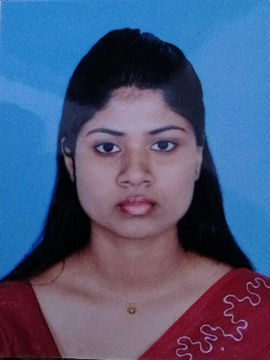

Address: 498/5/3-2 Aluthmawatha road, Colombo -15
Email: biyonikayashoda@gmail.com
Tele No: 0764499472, 0701171500
Gender: Female
Date of birth: 2000.01.05
Objective
I seek challenging opportunities where I can fully use my skills for the success of the company and I want to excel in this field with hard work, perseverance and dedication.

Professional Qualifications
- Completed by Certificate Course in English Language at National Institute of Business Management. (NIBM)

- Followed by practical English course at The Ministry of Public Administration and Management.
- Followed by Human Resources Management Course at The Ministry of Public Administration and Management.
- Following by Diploma in English course at National Institute of Business Management. (NIBM)

Academic Qualification

- Following by degree of bachelor of commerce (B.com) at university of sri Jayewardenepura

Educational Qualification

- . G.C.E. Advanced level - 2018 (Index No: 1003313)

Subject | Results
Economics | C
Business studies | C
Accounting | S
General English | S

- G.C.E. Ordinary level - 2015 (Index No: 50039482)

Subject |  | Results
Buddhist |  | A
Sinhala language & Lit. |  | B
Mathematics |  | C
History |  | C
Business studies &Accounting |  | C
Communication |  | C
Dancing |  | C
English | S
Science | S

- GIT Examination – 2017 (Index No: 1006290
Subject | Results
General information Technology | B

- Language Skills.

Name of language | Speaking | Writing | Understanding
Sinhala language | Very good | Very good | Very good
English language | Very good | Very good | Good
Tamil language | Average | Average | poor

- Personal information

- Name in full: Mahanthe Arachchige Yashoda Biyonika Rathnayaka

- Name with initial: M.A.Yashoda Biyonika Rathnayaka

- School: S.T. Anthoy’s Balika Maha Vidyalaya

- Date of birth: 2000.01.05

- Age: 19 years

- Gender: Female

- Nationality: Sri Lankan

- Religion: Buddhist

- NIC NO: 200050501342

- Civil states: Single

- Non Related References

Ravindra karawita S. Ediriwickarama
(Retired police officer – SSP) ( Retired police officer –SSP)
906/B Bogahajunction road, 54/8 A Pahaladodangahaheena
New town, Gothatuwa, New town,Gothatuwa
Angoda. Angoda
Tel: 0777122729 Tel : 011-2410099

I hereby that the above particulars are true and accurate to the best of my knowledge and belief this cv correctly describes me and my qualifications.

……………………………….. …………………………………..
Date Signature

